Method and System to Facilitate Voice Based Web Access with Blockchain
First A. Author, Jianwen Zhao,
Second B. Author, Prof. Bing Liu, and Third C. Author, Leland Lee, Blockchain at Berkeley
Abstract--In the same way Tim Berners Lee “invented” the World Wide Web, the Voiceweb Foundation is inventing the “next generation” WWW (World Wide Web): the voice-based web, or Voice Web. Whereas the traditional web was designed for the PC internet, we are creating a new web for the voice internet. To enable a voice-based internet world, we have to begin by creating a voice-based DNS (Domain Name System). In the area of “currency”, Bitcoin is a cryptocurrency that has gained some traction operating on the traditional web. As the traditional World Wide Web gives way to the Voice Web, we will begin to adopt VoiceCoin, a new cryptocurrency we are creating as a native aspect of the next generation Voice Web. VoiceCoin will be the money that powers the voice internet.

PROBLEM

T
im Berners Lee's World Wide Web includes three building blocks: URL (DNS+file path), HTTP, and HTML. His invention enables the PC internet and Graphic User Interfaces (GUI’s or “screens”). We are now moving into the Internet of Things (IoT) which will connect 75 billion devices by 2020.

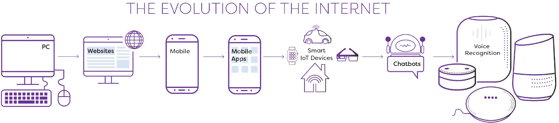
Instead of screens and keyboards, the vast majority of IoT devices will adopt Conversational User Interfaces (CUI), creating a dilemma: How will we input URLs? How will we make use of HTML? How can we transfer data using legacy HTTP protocol? In the age of voice, how can we make efficient use of the traditional WWW web?
Fig. 1. The Evolution of the Internet

Over the next few years, we will witness a major revolution in terminal devices, application user interfaces, underground protocols, and user behavior. This impending disruption requires that we overhaul Tim Berners Lee’s three key building blocks of the World Wide Web to meet the challenge. Otherwise, a handful of giant companies will continue to increase their domination of the World Wide Web and of everyday life. The next generation internet needs to reclaim and preserve the openness represented in the original internet

The largest technology companies in the world, Amazon, Apple and Google, are developing proprietary smart speaker products. It’s only a matter of time before these devices need to inter-operate with billions of other devices, resulting in the need for a decentralized new standard: the Voiceweb.

Smart speakers will be the Internet access points of the future. Unlike the traditional ways of accessing Internet services, people will activate the speaker by calling its name, and then use speech to access the various speaker-integrated services. The speaker’s integrated speech services are plugins (also called Skills or Actions) which must adhere to the standards provided by the speaker company. Generally speaking, these plugins take the form of a Chatbot. Under such a service system, the Chatbot’s name often times cannot be called directly. Speakers produced by different manufacturers require Chatbot developers to use distinct means of access, respectively. In the speakers produced by different manufacturers, each Chatbot’s name must be registered separately, otherwise the names may conflict, which also brings inconveniences to the user.

Every new speaker requires a developer to code interoperability functions, resulting in a mish-mash of code, languages, functions and user experience.

Unfortunately, the invocation name set by corporate developers like Google and Amazon works only with their own proprietary equipment; it is not a system that is open to the public. Facebook’s chatbot can be used only within Facebook; outside users cannot access it, and it’s not open to the public. With the aim of promoting the voice era and revitalizing the purpose of the web, the Foundation proposes an interoperated, decentralized invocation-name scheme, thereby improving web usage, bringing tangible benefits to internet users, and—to a certain extent—curbing the current centralized monopolization of this avenue of internet access by the internet giants.

At first glance, you may think our project is too broad and over-ambitious. However, the problem we will address is the current pain point or bottleneck for the entire Voice Internet and the IoT industry. The current bottleneck situation is comparable to the “Free WAP” era in the mobile internet due to the laggard World Wide Web. Like the mobile internet 10 years ago, the voice internet is still in a very early development stage. Now is time to leverage blockchain technology and cryptocurrency to create the necessary protocols for a rapid takeoff.

methodology

We initially analyzed some of the traditional Web's issues and proposed the concept of establishing a Voiceweb protocol stack. In this article we introduce the fundamentals of the Voiceweb protocol. We then, based upon this protocol, establish a preliminary Voiceweb infrastructure and its operational scheme. As to the structure of the Voiceweb protocol stack, we must principally summarize the Web's shortcomings and clearly establish the values and goals of standardization. Then, through an abstract comparison of traditional web protocols, combined with the demands of the latest industry trends and the feasibility of existing lead technology, we can build a preliminary Web protocol stack, continuously integrate aspects from every point of view, and then establish a relatively sound plan to promote and disseminate it to the entire industry.

First, we must thoroughly examine the issues of the traditional Web. John Berners-Lee's article the Web Foundation's March 12, 2017 issue claims that there are currently three major challenges to the web: the lack of control over user data, the proliferation of rumors, and the lack of transparency in political advertising. Why does the Web have these issues? In our opinion, these issues originate within the Web itself, and are determined by the technological conditions at the time of the WEB's infancy, and also by the decision to allow the Web to evolve using a "patchwork" mentality. Because of these limitations in technology, the lack of symmetry of the protocols of the early Web are specifically reflected in the following ways today:

When designing a protocol bundle, you should not only focus on the object being accessed by a user, but also give attention to the transmission of the protocol and to the user itself. The complete action of accessing the internet must for the most part include the user, the browser equipment, WEB content presentation, addressing protocols, and transmission protocols. From the aspect of WEB development, the establishment of WEB standards is seriously lagging behind the development of the industry. The most typical example is that although WAP protocol is used on a large scale, the WAP protocol is not formulated by the W3C. We have consulted the W3C to develop a new protocol stack, and still there has been no improvement. While they are trying to release W3C Coin, it is still just an attempt to do so.

The disruptiveness in the industry brought about by the arrival of the blockchain era has been vast, disturbing the traditional WEB on its most basic levels, and the traditional Web has made ongoing modifications to reconcile with these changes. But this approach is highly inadequate; therefore, we propose the Voiceweb Application Protocol to solve these issues. This protocol and a series of others form the BAP protocol stack. This protocol stack mainly divides the application layer, introduces the P2P protocol in the transmission layer, and adds an equipment and user identifier to the transmission layer within the application layer, thereby achieving a network of content distribution where tracking everything is possible.

The early web community produced some revolutionary ideas that are now spreading far beyond the technology sector:
Decentralization: No permission is needed from a central authority to post anything on the web, there is no central controlling node, and so no single point of failure … and no “kill switch”! This also implies freedom from indiscriminate censorship and surveillance.

Nondiscrimination: If I pay to connect to the internet with a certain quality of service, and you pay to connect with that or a greater quality of service, then we can both communicate at the same level. This principle of equity is also known as Net Neutrality.

Bottom-up design: Instead of code being written and controlled by a small group of experts, it was developed in full view of everyone, encouraging maximum participation and experimentation. Universality: For anyone to be able to publish anything on the web, all the computers

ANALYSIS

Due to its open nature, the World Wide Web (WWW, or the web) has been widely used and loved by the public since its inception. However, due to the transformative power of the Internet, we are seeing a reduction in the direct utilization rate of the Web in comparison with mobile applications, especially the social applications based on instant messaging platforms. In the Internet of Things (IoT) Era, the traditional Web may face an increasing number of issues. For example, when faced with a smart speaker, how does one input a website to browse a webpage? In the wake of the continuous development of the Internet technology, the Web must evolve in order to avoid marginalization by the global torrent of technological development. On the mobile devices side, we have experienced a very long period of WAP protocol utilization, which is evidence of the lagging development of the Web. So, the future of the Web in the IoT era, specifically in the era of voice Internet is not clear as of now Before blockchain development was thriving, the industry's widespread perception of Web 3.0 was by no means one of decentralization, but rather a kind of Semantic based Internet. This is merely an inference about the evolution of the browsing content itself. However, the Web has three essential elements: Uniform Resource Identifier (URI), Hypertext Markup Language (HTML), and Hypertext Transfer Protocol
(HTTP). It is not clear how these three elements may evolve in the voice internet era.

Mainly due to the inconvenience of the traditional domain name, and the resulting shift on the mobile Internet to application, the Web is getting caught up in centralized social
platforms, and becoming a kind of accessory, not globally accessible and open to all. In the IoT era, the traditional URI is becoming more inconvenient to use. From the HTTP protocol point of view, it is the Web protocol, and has been followed 5 by many important additions. Still, in the development of blockchain technology, HTTP and its related protocols may very likely be replaced. Therefore, due to the developmental requirements of the IoT, the voice Internet, and the decentralization of the Internet, the development of the Web requires a profound transformation. However, the traditional method of merely patching the Web cannot cure the underlying developmental issues. Particularly, this method cannot satisfy the developmental needs of blockchain, the Internet of things, and voice Internet. We urgently need to build new standardized Web protocols to thoroughly address these issues. We cannot rely on the W3C to do these things; their development of industry standards is falling seriously behind, which has led to the persistence of old problems and
the emergence of an endless stream of new problems. The web standards may be gradually restructured over time, but this would take a great many years.

According to an article by John Berners-Lee's [John Berners-Lee, “Three challenges for the web, according to its inventor”, https://webfoundation.org/2017/03/web-turns-28-letter/, March 12, 2017], there are currently three major challenges to the web: the lack of control over user data, the proliferation of rumors, and the lack of transparency in political advertising. These issues originate within the Web itself and are determined by the technological conditions at the time of the web’s infancy, and by the
decision to allow the Web to evolve using a "patchwork" mentality. Because of these limitations in technology, the lack of symmetry of the protocols of the early Web are specifically reflected in the following ways today.

- The traditional web lacks attention on the viewer
itself. In the ordinary PC server, we are only aware of the user's IP address, but we do not know the user's identity. This brings with it a very serious problem: whenever we visit a new website, we must register or login again, which is extremely inconvenient to Internet users. In the mobile Internet, such as in the IOSTM system, this issue is to some extent solved, but AppleTM may not release the user's login information to the user itself. Although the AppleTM application gives the public a convenient means of payment, it has not helped users solve the issue of a unified means of authentication on the Web. Even further, AppleTM provides application services, not web services; thus, the Web appears to be taking a back seat in the era of the mobile internet. Users are using browsers less and 5 less to access web pages. The web is becoming a mere lackey to the instant messaging tool, where the very essence of the open web is not reflected or sustainable.

- In traditional web protocols there is no attention paid
to the specific equipment / device used by the consumer. We know the type of device and network browser used by the visitor, but we don't know the browsing device /ID number. This is a huge drawback to the arrival of the time when all things are connected and has become a significant loophole in the current protocols. There is good reason for all devices worldwide to have to have a uniform identifier, especially under the technical requirements of IPV6 and blockchain; We need the capability to track every viewer and every browsing device.

- There is a general lack of attention given to User
Generated Content. The arrival of WEB 2.0 has certainly brought about a great deal of success in its application; however, users still cannot properly protect their intellectual property, and we cannot track the widespread propagation of rumors. In the era of blockchain we may solve this problem, as any created content may be closely bound to and associated with the user. Regardless of the user switching applications, the digital registration of the property is always there. This may solve the question of intellectual property ownership of digital assets and at the same time the problem of the propagation of unfounded rumors on the Web.

- There is currently no single, universal method for
payment. On the mobile side, we may use Apple pay, but on the web side, we find this type of payment to be difficult. We may think this to be reasonable, but in actuality this difficulty is caused by the drawbacks of WEB design. Each time they visit a new site, the users must once again enter a payment method. Moreover, aside from the security and reliability issues of this type of payment process, there are inter-national currency issues that arise as well.

- The Web protocols are not based on a user centric
design and lack attributes that promote social interaction. Shortcoming 1 has resulted in the decentralization of the Web, which has made it more inconvenient to use. Web Browsers try to create products such as favorites, but this is extremely inadequate. This gives the social networking websites huge opportunities for exploitation. We have noticed that the public's use of social networking software for outstrips that of browsers. The use of the Web via social networking software is understandable, but this poses a serious problem, 5 that is, social networking sites monopolize the Web and 'kidnap' the user, resulting in the fragmentation of the WEB: social networking sites such as Facebook and WeChat are not interoperable; thus, users of these websites cannot freely interact with each other.

- The design of the URI is contrary to human nature. In
the early days of the Internet, a very scientific format was used for domain names to identify a website, and this form met the needs of that time. But in the mobile Internet era, such a form is highly inconvenient. The users prefer to simply enter keywords to find content and like to search for related entities based on natural language names in social networking software and to establish one-way relationships of interest. After the arrival of the Internet of Things, the old model may be unusable; we cannot enter a URL using a device like Alexa. Therefore, the domain name needs a revolution, and a new system needs to be established based on natural language.

- HTML and other related content descriptor language
types may be suitable for a browser, but are they suited to a voice-based Internet? The future of the Internet are applications based upon a voice-based graphic interface platform, not the reverse. Traditional HTML simply may not be able to handle the related issues. We have also seen the birth of Virtual Reality Modeling Language (VRML), but how do VRML and HTML impact each other? In fact, no one is working to resolve this issue. Due to the severely lagging nature of W3C's WEB standardization, the users just passively wait for new technical standards to emerge, and then to great disadvantage, try to reconcile the technologies. In the Semantic era, VRML and traditional HTML, must be able to coexist within one system.

SOLUTION: voice Application protocol

By 2020, Morgan Stanley predicts 75 billion devices may be connected over the Internet of Things. In 2016, messaging platforms topped social networks in their share of human attention. And voice is rapidly becoming the preferred channel for human interaction with web-enabled devices. When interacting with the thousands of smart devices that lack graphic user interfaces, the users naturally choose voice over keyboards, meaning we are witnessing the decline of the traditional web browser. Many companies and developers are focused on the emergence of the voice-based internet, but standards are fragmented. Each smart speaker manufacturer, for example, must ask chatbot developers to learn its proprietary protocols and 5 register chatbots company by company so that the chatbots may be browsed by end users. This fragmented approach wastes developer time and resources. Several major players such as Alexa are emerging to consolidate the market, but these players may formulate rules, centralize control, limit user experience, profit from the personal data they capture, and be unable to guarantee personal data security. Therefore, there is a need for improved methods, systems, servers and protocols to facilitate voice-based web access that may overcome one or more of the abovementioned problems and/or limitations.

The Voiceweb Foundation is creating a WWW 2.0 protocol stack with a particular focus on creating a decentralized, voice-enabled DNS system. Namecoin was trying to develop a decentralized DNS, but the team never found an appropriate target market. The Voiceweb Foundation is now creating a voice enabled, decentralized DNS, which will solve the Voice Internet naming problem for the IoT industry.

By applying blockchain technology. Speaker Chatbots can be named and uniformly registered following the Voice Domain Name Protocol on an open blockchain platform. All Chatbots have their own name, and have their own unique ID. Smart speaker manufacturers can utilize the open resources of blockchain, breaking the information island, promoting the sharing of industry information and reducing access issues for developers. Voice DNS provides a simple and convenient protocol to integrate smart speaker services. As long as a person can speak the name of the service they want to access, they can do so from anywhere, using any smart speaker, and thus these services can be available in any corner of the world. This opens speech services to the public domain and gives speech-based service brands the opportunity to emerge. Based upon these voice characteristics, we call this open blockchain platform for Chatbot name registration Voiceweb. Developers can register their own Chatbots on the blockchain, thereby sharing the goal of the smart speaker manufacturers with the entire world. Thus, after a smart speaker is launched, any smart speaker user can access a Chatbot’s services by simply calling its name.

This summary is provided to introduce a selection of concepts in a simplified form, that are further described below in the Detailed Description. This summary is not intended to identify key features or essential features of the claimed subject matter. Nor is this summary intended to be used to limit the claimed subject matter’s scope. There is a need to redefine the three models of URIs, HTML and HTTP, based on the requirements of current times. Accordingly, the Web may start with the transformation of the domain name, content presentation, network protocols, and even more layers of protocol stacks to establish an entirely new set of industry standards and model applications, only in this way, a globalized standard may be reached. The traditional web is decentralized, open to the public, and global.

According to some embodiments, a new web (Voiceweb) is disclosed. The Voiceweb is different from the merely decentralized Web 3.0 as Voiceweb is a kind of fusion. Each layer of Web protocol may be modified to set a whole new standard, the basic form of which is not only decentralized, but also conversation based, and with much more advanced features.

Further, Voiceweb may use decentralized blockchain technology to redefine Internet protocols and rebuild a new common Internet infrastructure. The Voiceweb will solve the three major challenges to the Web: the rise of rumors, the loss of control over user data, and the lack of clarity in political advertising. In fact, the root cause of these challenges is the lack of symmetry regarding Web protocol. This lack of symmetry is mainly reflected in the lack of support for KYC. Through the traditional WEB, applications have difficulty tracking the user's identity and behavior. Voiceweb may bring this resolution into being by way of a completely new and robust Web that promises even further development. Voiceweb may not replace the traditional web, rather it may revitalize the traditional web. Further, blockchain may underpin the voice-based internet, including a decentralized voice-based domain name system.

Many new conversational applications (also called intelligent assistants, bots or agents) for robot, IM platforms, smart devices and mobile applications are being developed. However, these types of applications/ centralized platforms are far away from the original internet spirit, a decentralized internet should be the future. Even the innovators of internet would not like to see the internet are sliced by centralized platforms. The present disclosure seems to provide an innovative approach to revitalize world of web with blockchain technologies.

A decentralized voice naming service will release the exhausted internet name resources. The users will develop their conversational apps in our protocol such that their application may be browsed by the users all over the world. Since the protocol follows the decentralized spirit of the users, the users are free to talk, with no worries about intermediary inspection. Furthermore, a Voicecoin is provided for the users to use. With this coin, the users may pay services and commodity provided by the conversational apps.

The transactions, messaging, naming assets, are all protected with our block chain technologies. Both the foregoing summary and the following detailed description provide examples and are explanatory only. Accordingly, the foregoing summary and the 30 following detailed description should not be considered to be restrictive. Further, features or variations may be provided in addition to those set forth herein. For example, embodiments may be directed to various feature combinations and sub-combinations described in the detailed description.

By constructing a user-centered hierarchical network system and combining the powerful technology of blockchain, we construct Bitweb protocol stack, which is very instructive for the design of blockchain products. The specific advantages lie in many aspects. The first is to cater to the development of the Internet of Things era, with presentation layers supporting natural language conversations and based on which hyperlinks to the content of the conversation can be developed. Second, to ensure privacy and security. Through decentralized design, users' data will not be exploited by centralized organizations nor will they be leaked. Based on social networks, this is an emerging social network where people can build a global network. More natural domain name system, using natural language can access the web site. Be able to track everything, ensure that your digital assets are protected and prevent rumors from being spread. Support for such protocols will reduce frequent sign-in for switching between applications. This undoubtedly brought great convenience for the user. Notice, each agreement, are to be further detailed definition, not just such a simple division.
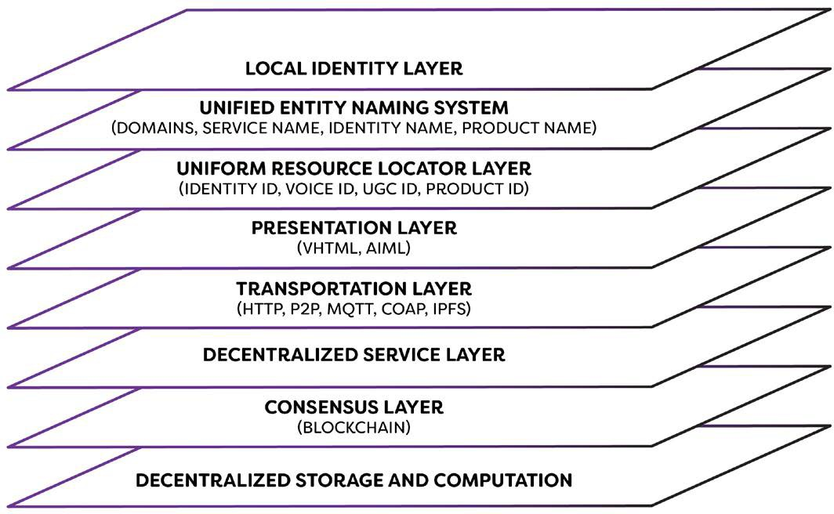

Fig. 2. Voiceweb Protocol Stack

- LOCAL IDENTITY LAYER

What's the scope of the what we called next generation of internet of things? The internet is what we called next generation of internet of things. All devices connected are open, not limited by any giant carriers. Speaking, any devices will be turned into a kind of bot browser. People can talk to any bot through this device. While, the bots are the applications of the future internet.

- UNIFIED ENTITY NAMING LAWYER

A local Naming repository supported. When you call some name, the bot will firstly look for the device based on locations. People can bind their alias. Relations – stored locally and decentralized, privacy protected by encryption algorithm. The users won’t have to remember the receiver's addresses for different currencies, or any other specific data: they will be able to send to a username or via a QR-code.

Naming system is a basic component of the conversational Web. Meanwhile, naming system should be different, it should be decentralized and constructed in nature language. In Naming System, people can only use one registered name to find services. Anyone can create the name of their bots. Every bot can have a character name in nature language. Hence people can just call its nature name to find it. Compared to the old domain name, it is on the block chain, to the center of the. Any of us, can be registered in their own domain name, can be in this new Internet world, to win their place, to prove their presence! it is the use of natural language to register.

Search engine and Naming service, either of them is a kind of tool for user to find the services. In search engine, people can user more keywords to find services. Search engine is on top of Naming layer. Search engine is a kind of extension of Naming Layer. People register their name on Naming Layer. Search engine label services name in its database.

- UNIFORM RESOURCE LAWYER

The blockchain makes each resource on the Internet have a unique ID, making it possible to track users and resources. After the user enters the Voice World Wide Web, all his/her actions can be tracked. Whatever times the content created by the user is shared, the original creators can still be found. Blockchain technology can track user behavior and prevent the spread of rumors; user generated content (UGC) has copyright protection. Cryptography technology is enabling users personal information and privacy are fully protected.

- PRESENTATION LAWYER

This layer, provide an interface for user to find its applications. Help for people to find their bots. This browser, the form of the interface, then support the importation of the domain name, no interface under the form of support through the voice to access the existing and future Internet services. Its operating principle, with the existing smart speaker equipment is different from the application to apply for stationed in these, but the docking of our services.

Which will be installed in smart devices. This is the block chain underneath the ecosystem. Chat Chain, is our product collectively, it is a chain of services to provide the block chain, based on the chain of chain services and protocols, any intelligent devices, can be transformed into an Internet browser, can help people achieve the Internet Function. Conversation contracts – any transaction happens in this platform will follow the rules of smart contracts. This also include bot coin transactions.

In a conversation web, website exists with a form of bot. The bot is semantic, conversational user interface based. In the conversational context, graphic user interface is just part of it, it appears when needed. When people is using bot site, graphic user interface will not always necessary. But with the development of the internet, the first interface that people use internet, should be conversational interface based.

- TRANSPORATION LAWYER

Message include P2P message, broadcast. Anyone who is free to speak, should not be subject to review, chat content, should also be highly confidential. The message between users, not sent to the central server to forward, but through the point to point to complete. The main mechanisms, including point-to-point communication, end-to-end encryption, first with the first letter, message survival and executable distributed contracts. This facility allows individuals to keep secure information, deal with transactions, and track them through many centrally located books.

- CONSENSUS LAWYER

On blockchain layer, we store transactions of users’ cash equivalent, digital asset, social asset. The stack consists the transactions that are going to happen on the chain. The transactions consist of multiple items, such as domain name creation, virtual gifts purchasing, emojis purchasing, etc.

All crypto currencies, tokens, are kind of cash equivalent. These kind of equivalent is a kind of gasoline for the entire blockchain infrastructure to run smoothly. The currencies also using as a payment for purchasing virtual gifts, emojis, and the provision of payment for access to third-party applications. Because our currency is used globally, it can effectively solve the traditional instant messaging software using traditional currency transnational transmission of many problems.

- DECENTRALIZED STORAGE
AND COMPUTATION

In this Layer, people’s data is stored. All social related content should be traceable and stored in this layer. By this means, users privacy can be protected. Data security will be guaranteed. Decentralized account. With this, all people don’t need to register any longer for different of bots. They just need one account to resolve all their problems. Verification, and binding alias name, and other properties.

Users connections, relationship is a kind of intangible social asset, should be confidential. Users profiles, timelines are kind of intangible digital asset, should be traceable with a unique identity. Profile includes users photo, public signature and theme design. Timelines include the content that people original created, including video, photos, tweets, etc.

The Voiceweb Application Protocol (VAP) stack is a tiered network system that integrates blockchain technology to enable a decentralized voice internet. It offers users an easier, safer, and more open browsing experience than the World Wide Web.

Easier. Presentation layers allow people to use natural language to access and browse the internet. The digital-identity
layer means that people won’t have to sign in every time they use a new application.

Safer. The Digital ID and the Cash Equivalent layer make payments and digital-asset access and protection simpler and
more secure. It also makes it very difficult for people to create fake identities and disseminate content anonymously.

More open. Because of its decentralized nature, Voiceweb users’ personal information and data can’t be exploited or
leaked by centralized platforms and organizations.
Obviously, each protocol layer requires further explanation. In reality, they’re not as simply divided as indicated in the
diagram.

V-DNS

Within this Voiceweb system, we call these chatbots DBot, or DBot Site. The Smart Speaker will utilize its own network browser, which we call DBot Browser. We call the blockchain chatbot naming System V-DNS and we call the encrypted digital currency that would be needed for the chatbot system Voicecoin. Voicecoin is based upon the principles of Namecoin, but the distinguishing characteristic is that it is based on the system of a natural language domain name. The domain name address is permanently bound to the DBot service address.
Many have noticed that Protocol Labs is trying to replace HTTP with their IPFS. HTML, it appears, will also be updated to conversational HTML. URLs and especially DNS, will be updated to a voice enabled DNS system. This is precisely what we aspire to create: a Voice Naming System (V-DNS) for the next generation DNS that is more advanced, decentralized, and secure than the traditional DNS because it is developed based on blockchain technology. In its initial stage, Voiceweb will be the currency that powers this V-DNS.

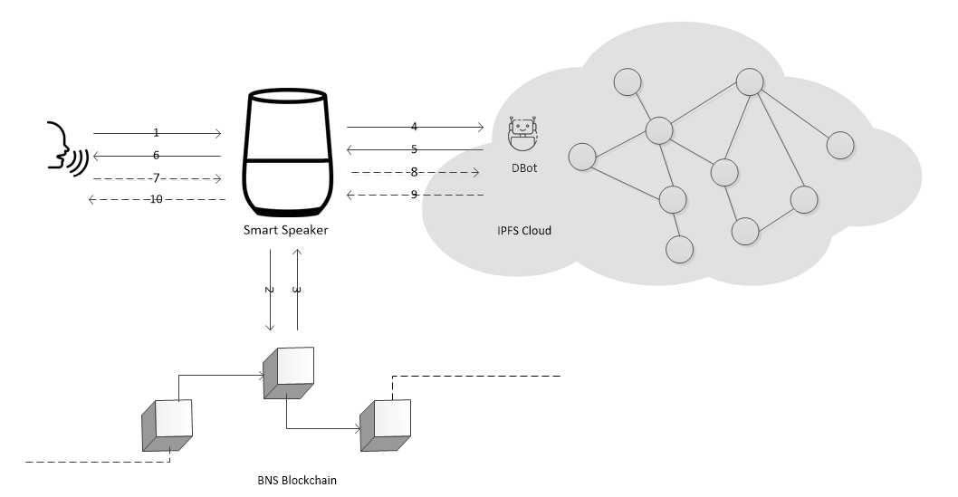

Fig. 3. How V-DNS works

The above illustration shows the working principals. Once the user activates the device's Smart Speaker, they speak the name of the chatbot (step 1). Based upon the user's command, the Bot Browser within the Smart Speaker then queries the chatbot's URL address via the V-DNS blockchain interface (step 2), and the V-DNS interface returns the chatbot's address (step 3). Based on the chatbot's address, Bot Browser accesses the IPFS Cloud based DBot, DBot sends the first request (step 4), and DBot then replies (step 5). The Bot Browser utilizes the Smart Speaker's voice interface to play the chatbot's reply (step 6). After the user hears the chat bot reply, he or she can decide whether to reply (step 7). If you reply, then the dialogue is passed to Dbot via the Smart Speaker's Bot Browser (step 8), and DBot then returns the reply (step 9). Bot Browser then transmits the reply to the user (step 10).

voice enabled HTTP

Within these sessions, the communication protocol between the Bot Browser and the DBot can initially be via HTTP or perhaps HTTPS, and later can take the IPFS protocol. The Bot Browser protocol of querying based upon the chatbot name address is no longer a conventional DNS resolution service, but is instead a new RMI means of transfer. Voiceweb Foundation is committed to standardizing this protocol, committed to blockchain, and will be the only industry-wide user of such a domain name service. For the cloud hosted DBot Site, Voiceweb will adopt an open source strategy that will help establish a unified voice-over-internet network instead of being monopolized by centralized forces, which is a boon to the clear majority of users. Below is a more detailed look at the process of domain name resolution:

With regards to the principal behind the Bot Browser; This is the basic principle of the chatbot dialogue for reference, used to illustrate the general principals of the Bot Browser:

The user speaks, the Smart Speaker converts speech to text (ASR) then hands it off to the Bot Browser which sends the request to the DBot. After the DBot receives the request, the user's intention must first be understood, and then to the session state for processing (DST), which in turn submits to the session Strategy (DP), which then generates the reply language (NLG), and returns the reply to the Bot Browser, the Bot Browser then sends its request to the speaker, the system will convert the text to voice (TTS), and then broadcast to the user. This describes the process for a complete conversation.

It must be understood that there are numerous sub-types of chatbot; this schematic is of a simple chatbot that can support many types of conversation. Also, we are currently developing the Bot Browser software. Many Smart Speaker Operating Systems and Bot Browsers are not open source, and can thus handle only their own Skill interface. We define this Bot Browser as an open source domain name based chatbot system, based on the Voiceweb protocol that is open to developers around the world, to embed the software within smart speakers / devices. We are committed to seeing this software embedded into any internet capable IoT device.

VHITP is generalizable to other blockchains, leveraging the technology developed for V-DNS now anyone can use their voice to interact with DApps on other blockchains outside of Voiceweb and pay with Voicecoin without the need for the native currency. In order to use this channels must be established with other blockchain to create a bidirectional connection. This generalizable interface allows any blockchain
Fig. 4. How VHTTP works

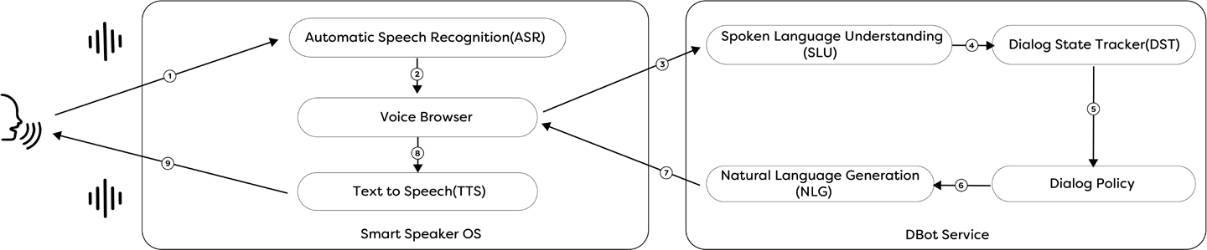
with a primitive scripting language to be connected to the wider internet of blockchains as a whole. Data propagation is bidirectional, clients can use V-DNS to communicate and interact with any DApp on any arbitrary blockchain and DApp can communicate cross chain to other DApp if they desire to. Cross chain interoperability allows blockchains to scale and interact with each other in ways that were not previously conceivable. It’s also possible to tokenize assets onto VHITP. Using SPV proofs and federated pegs one can move coins from one chain onto the other. This bridge is known as a 2-way peg

Voice web Presentation Protocol

With regards to Chatbot's Presentation Layer, Voiceweb aims to create a Conversation HTML protocol. The periphery of this HTML protocol is AIML language, embedded into the HTML page as needed. Based on this, if the user's Smart Speaker support interface is displayed, the embedded interface is displayed on the screen or projected on the VR device and mapped on the AR device. Voiceweb is committed to making this the industry standard, the most important aspect being interoperation. That is, giving the chatbots the ability to reply.

How do you handle those cites that do not specify a domain name? By way of a Slot Filling method of using part of the text of the traditional domain name to query the site, these traditional sites can become automatic query and response chatbots. For such a service, an agent would need to be established to handle these inquiries. During the early stages of Voiceweb this kind of service is necessary. Today's query and response technology is still insufficient, and its accuracy within the entire industry is lacking; the goal is to strive for constant improvement.

On traditional web pages, hyperlinks link web pages together. But when chatting between bots, how do you transfer a conversation to another chatbot? This is a problem we need to solve with Voiceweb Conversational HTML. Within a chatbot conversation, you can specify the address of another chatbot so that if the chatbot cannot answer a question, it can recommend another chatbot. There are two mechanisms for implementing this: One is explicitly specifying within the text of the conversation and in the form of an anchor, the name of another chatbot and the corresponding service address. In this way, if the user specifies that this chatbot respond to the specific inquiry, the browser will switch the user to that chatbot. An agreement would be necessary in this situation.

Another form is implicitly specified. This form, generally through the chatbot internal procedures, through a technology called NER to automatically identify the type of entity, automatically request V-DNS to get the address of the chatbot, and then fill in the reply to the CHTML. In this way, the user can use voice conversation to achieve the jump. Of course, the user can also use the password to request Bot URL to switch websites. These instructions would operate according to the different natural language and different definitions. So this mechanism would try to follow the user's intent in its operation, rather than simply follow fixed instructions. Such a Bot Browser is highly intelligent and technically complex, and is still a way off in the future.

Regarding speech performance, including tone, intonation and various auxiliary formats: Different speakers must be able to play the same sounds. This is an issue that will need to be resolved. The voice of different Bots should be different, and can be definable. In CHTML, not every CHTML includes both Q & A and HTML. Instead, the beginning of a conversation is in the form of dialogue and HTML content is returned as needed.

The server returns a request by a variety of ways, one is to directly return all the answers to the JSON file, cached in the client, with the browser responsible for resolution and response. The other is that every time there is a Q & A session, the server-side interface is queried to return the request. When the developer sets the application name, it can be analyzed via semantics.

implication

With reference to FIG. 15, a system consistent with an embodiment of the disclosure may include a computing device or cloud service, such as computing device 1500. In a basic configuration, computing device 1500 may include at least one

processing unit 1502 and a system memory 1504. Depending on the configuration and type of computing device, system memory 1504 may comprise, but is not limited to,volatile (e.g. random-access memory (RAM)), non-volatile (e.g. read-only memory (ROM)), flash memory, or any combination. System memory 1504 may include operating system 1505, one or more programming modules 1506, and may include a program data 1507. Operating system 1505, for example, may be suitable for controlling computing device 1500’s operation. In one embodiment, programming modules 1506 may include image-processing module, machine learning module and/or image classifying module. Furthermore, embodiments of the disclosure may be practiced in conjunction with a graphics library, other operating systems, or any other application program and is not limited to any particular application or system. This basic configuration is illustrated in FIG. by those components within a dashed line 1508. Computing device 1500 may have additional features or functionality. For example, computing device 1500 may also include additional data storage devices (removable and/or non-removable) such as, for example, magnetic disks, optical disks, or tape. Such additional storage is illustrated in FIG. 15 by a removable storage 1509 and a non-removable storage 1510. Computer storage media may include volatile and nonvolatile, removable and non-removable media implemented in any method or 30 technology for storage of information, such as computer-readable instructions, data structures, program modules, or other data. System memory 1504, removable storage 1509, and non-removable storage 1510 are all computer storage media examples (i.e., memory storage.) Computer storage media may include, but is not limited to, RAM, ROM, electrically erasable read-only memory (EEPROM), flash memory or other memory technology, CD-ROM, digital versatile disks (DVD) or other optical storage, magnetic cassettes, magnetic tape, magnetic disk storage or other 5 magnetic storage devices, or any other medium which can be used to store information, and which can be accessed by computing device 1500. Any such computer storage media may be part of device 1500. Computing device 1500 may also have input device(s) 1512 such as a keyboard, a mouse, a pen, a sound input device, a touch input device, a location sensor, a camera, a biometric sensor, etc. Output device(s) 1514 such as a display, speakers, a printer, etc. may also be included. The aforementioned devices are examples and others may be used. Computing device 1500 may also contain a communication connection 1516 that may allow device 1500 to communicate with other computing devices 1518, such as over a network in a distributed computing environment, for example, an intranet or the Internet. Communication connection 1516 is one example of communication media. Communication media may typically be embodied by computer readable instructions,
data structures, program modules, or other data in a modulated data signal, such as a carrier wave or other transport mechanism, and includes any information delivery media. The term “modulated data signal” may describe a signal that has one or more characteristics set or changed in such a manner as to encode information in the signal. By way of example, and not limitation, communication media may include wired media such as a wired network or direct-wired connection, and wireless media such as acoustic, radio frequency (RF), infrared, and other wireless media. The term computer readable media as used herein may include both storage media and communication media. As stated above, a number of program modules and data files may be stored in system memory 1504, including operating system 1505. While executing on processing unit 1502, programming modules 1506 (e.g., application 1520 such as a media player) may perform processes including, for example, one or more stages of methods, algorithms, systems, applications, servers, databases as described above. The aforementioned process is an example, and processing unit 1502 may perform other processes. Other programming modules that may be used in accordance with embodiments of the present disclosure may include sound encoding/decoding applications, machine learning application, acoustic classifiers etc. Generally, consistent with embodiments of the disclosure, program modules may include routines, programs, components, data structures, and other types 5 of structures that may perform particular tasks or that may implement particular abstract data types. Moreover, embodiments of the disclosure may be practiced with other computer system configurations, including hand-held devices, general purpose graphics processor-based systems, multiprocessor systems, microprocessor-based or programmable consumer electronics, application specific integrated circuit-based electronics, minicomputers, mainframe computers, and the like. Embodiments of the disclosure may also be practiced in distributed computing environments where tasks are performed by remote processing devices that are linked through a communications network. In a distributed computing environment, program modules may be located in both local and remote memory storage devices.
Furthermore, embodiments of the disclosure may be racticed in an electrical circuit comprising discrete electronic elements, packaged or integrated electronic chips containing logic gates, a circuit utilizing a microprocessor, or on a single chip containing electronic elements or microprocessors. Embodiments of the disclosure may also be practiced using other technologies capable of performing logical operations such as, for example, AND, OR, and NOT, including but not limited to mechanical, optical, fluidic, and quantum technologies. In addition, embodiments of the disclosure may be practiced within a general-purpose computer or in any other circuits or systems. Embodiments of the disclosure, for example, may be implemented as a computer process (method), a computing system, or as an article of manufacture, such as a computer program product or computer readable media. The computer program product may be a computer storage media readable by a computer system and encoding a computer program of instructions for executing a computer process. The computer program product may also be a propagated signal on a carrier readable by a computing system and encoding a computer program of instructions for executing a computer process. Accordingly, the present disclosure may be embodied in hardware and/or in software (including firmware, resident software, micro-code, etc.). In other words, embodiments of the present disclosure may take the form of a computer program product on a computer-usable or computer-readable storage medium having computer-usable or computer-readable program code embodied in the medium for use by or in connection with an instruction execution system. A computer-usable or computer-5 readable medium may be any medium that can contain, store, communicate, propagate, or transport the program for use by or in connection with the instruction execution system, apparatus, or device. The computer-usable or computer-readable medium may be, for example but not limited to, an electronic, magnetic, optical, electromagnetic, infrared, or semiconductor
system, apparatus, device, or propagation medium. More specific computer-readable medium examples (a non-exhaustive list), the computer-readable medium may include the following: an electrical connection having one or more wires, a portable computer diskette, a random-access memory (RAM), a read-only memory (ROM), an erasable programmable read-only memory (EPROM or Flash memory), an optical fiber, and a portable compact disc read-only memory (CD-ROM). Note that the computer-usable or computer-readable medium could even be paper or another suitable medium upon which the program is printed, as the program can be electronically captured, via, for instance, optical scanning of the paper or other medium, then compiled, interpreted, or otherwise processed in a suitable manner, if necessary, and then stored in a computer memory. Embodiments of the present disclosure, for example, are described above with reference to block diagrams and/or operational illustrations of methods, systems, and computer program products according to embodiments of the disclosure. The functions/acts noted in the blocks may occur out of the order as shown in any flowchart.

For example, two blocks shown in succession may in fact be executed substantially concurrently or the blocks may sometimes be executed in the reverse order, depending upon the functionality/acts involved. While certain embodiments of the disclosure have been described, other embodiments may exist. Furthermore, although embodiments of the present disclosure have been described as being associated with data stored in memory and other storage mediums, data can also be stored on or read from other types of computer-readable media, such as secondary storage devices, like hard disks, solid state storage (e.g., USB drive), or a CD-ROM, a carrier wave from the Internet, or other forms of RAM or ROM. Further, the disclosed methods’ stages may be modified in any manner, including by reordering stages and/or inserting or deleting stages, without departing from the disclosure.

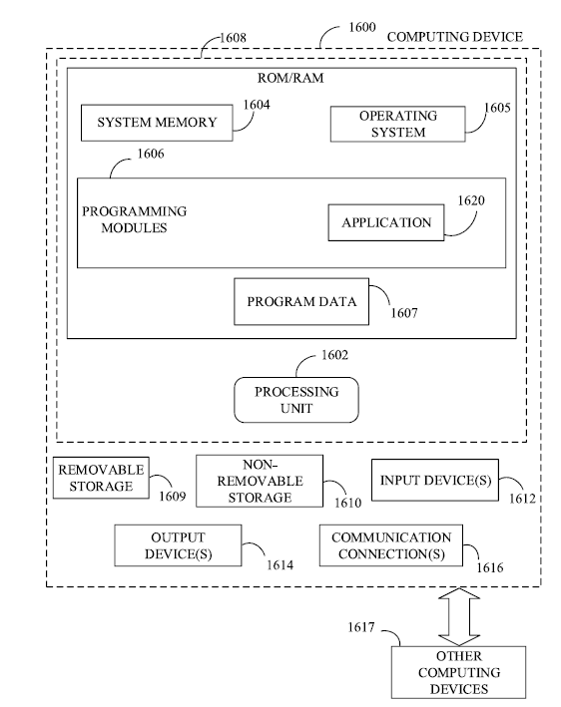

Fig.5 . How IoT device works

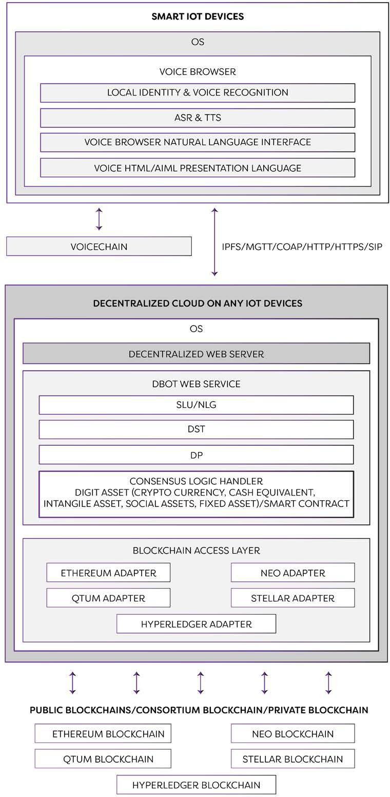
A instance to implement this new internet.

Fig. 6. ARCHITECTURE

- Overall architecture

Immediately following Chatbot registration, each chatbot has a formal name. Using the appropriate browsing equipment, the user can find the address of a chatbot by using the domain name. We call this chatbot name the Voice Name. To resolve the issue of duplicate names, we introduce the concept of the Voice Domain, where chatbots can share the same name in different voice domains. In this way, as long as the smart speaker can identify the voice domain through voice recognition and find it on the voice domain, the Chatbot can be found via the Voice Name.

- V-DNS

The Below illustrates the V-DNS blockchain system architecture: V-DNS blockchain will provide registration, deletion, lookup and transfer of domain names. These services will take the form of smart contracts deployed within V-DNS blockchain. Smart contracts run on the V-DNS blockchain's Voiceweb Virtual Machine (VVM). V-DNS blockchain also provides mining capabilities and automatic issuance of Voicecoin

Due to the low real-time registration requirement of the domain name system, the requirements for reliability are high, we therefore employ the common mechanism of PoW to implement the contract and assist in the domain name check. As to the currency issuance mechanism:

- HUMAN-MEANINGFUL
Wilcox-O’Hearn proposes the following three properties for naming protocols: human-meaningful, decentralized, and secure. V-DNS possesses the characteristics of all these and more, owing to the integration of voice features combined with blockchain technology. Human-meaningful is a common domain name system, it is user-selected and easy to remember. VNS accomplishes this, being easily recognized by the ear, unambiguous, and suitable for use on the voice Internet. Voiceweb’s primary feature is voice. The design of voice domain name rules is not on the state’s constant suffix, but in the form of dialogue with people. The actual situation is that the traditional top-level domain names are gradually coming out with more natural language features, but the development is very slow. Adding a gTLD (Generic Top-Level Domain) is troublesome. In addition to the technical issues of efficiency and scalability, NAMECOIN only supports .bit suffixes in product features, and does not support other suffixes. Extended support for the domain name is poor, and scalability is poor. For example, it does not support Txt records. Blockstack is a virtual chain implementing an abstract state machine that works on other blockchain platforms. State machines are used to perform a variety of services, including the identity service OneName, which in theory can execute any service. Solving part of NAMECOIN’s technology issues, there are many others that allow users to own their own data, but they do not support a natural language domain name.

- CONVENIENT
Voicecoin provides an intimate and natural interface between human and computer while reducing the cost of interactions. Voice, as a natural method of login and payment, serves as a core factor permeating the entirety of the voice Blockchain. Voicecoin, the voice Blockchain, and its peripheral products, is the main distinguishing factor from other currencies and services. Voicecoin, will allow people to trade domain names. People can pay for any service on any accessible voice blockchain using VoiceCoin. When not logged-in, you can utilize the chatbot services. When logged-in, you can take it a step further, and even initiate payment via the chatbot. This product was designed to utilize the distinguishing characteristic of speech, from wallet authentication and login to the registration of domain names, and even the provision of chat services. Using voice, people can log in to the wallet; using the voice wallet, people can register the voice featured domain name. Using Voicecoin, people can chat with chatbots
over speech-enabled devices.

- DECENTRALIZATION2
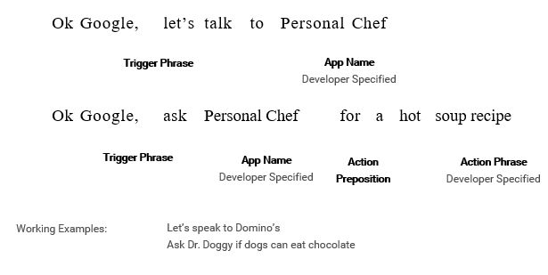
Traditional VNS is based on ICANN, but VNS is completely different; it runs on a decentralized blockchain. It can be executed by anyone, but cannot be controlled by anyone. Each node runs independently and does not depend on any third-party services.

- SECURITY3
Under the traditional VNS mechanism, HTTPS protocols are used to solve the problem of VNS hijacking. However, the website needs to rely on the certificate authority’s guarantee (the “CA”). If any one of the thousands of CAs is attacked, makes a mistake, or is forced by a government, it may issue false certificates / credentials. Decentralized VNS does not need to rely on CA, and nobody can easily hijack VNS domain names. Traditional VNS is very weak; if a node is attacked, then there could be domain name resolution accidents. In some areas, domain name registration is subject to real name authentication, and for domain name offering services, you must first pass a governmental examination.

VNS Cache Pollution often directs users to different addresses. A DDoS attack occurred in 2016 against VNS provider Dyn, rendering companies such as Amazon, Paypal, Reddit and GitHub unable to provide normal services.

- CENSORSHIP-RESISTANT
With traditional VNS, the government can block certain website’s accessibility, but this is not done so easily with VNS. In some areas of the world, including China, websites are often not accessible due to government censorship. But VNS is built on Blockchain technology, and every domain When the developer sets the application name, it can be analyzed via semantics name is accessible the user’s computer without tampering.
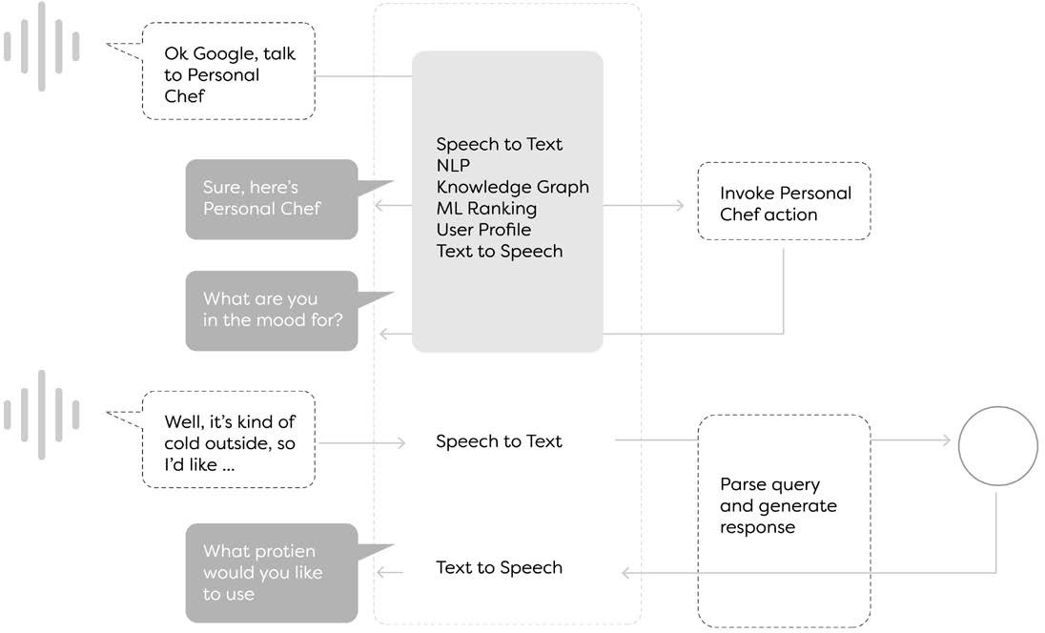
- PRIVACY PROTECTION
Under traditional DNS, based upon the consumer’s IP address, the VNS server can track the consumer’s activity / history. A Blockchain-based domain name system, like VNS, avoids this by not producing any network tracking when users visit a site.

- LIGHTNING-FAST
Traditional domain name switchover generally requires 24 to 48 hours, which results in unnecessary service downtime. But Blockchain based VNS can very quickly update the domain name list. Traditional VNS resolution time is slow, generally over 100 milliseconds. The VNS maintains its domain name list locally, and thus resolution time is less than 3 milliseconds.

- SUPPORTS ANONYMITY
VNS can direct users to anonymous hosted Web sites on Tor and I2P anonymous networks. Unlike Tor’s
.onion domain (made up of random letters and numbers) or I2p’s .i2p domain, which can direct different
crowds across different websites), VNS provides both Tor and I2P hosting with suitable, readable, and
definitive VNS analyzation service.

- RESOURCES RELEASED
VNS establishes a process that allows people to fully release their domain name resources.

- INTEROPERABILITY
When sharing the same basic form of domain name, global chatbots will be able to communicate with each other across platforms. For example, the traditional WeChat public number can’t talk to Facebook’s chatbot, but VNS breaks this limitation.

- RESOURCE SHARING
By removing the individual, stand-alone domain name systems of the smart speaker manufacturers, we establish a unified domain name system which strengthens information sharing and reduce the number of intermediaries involved in consumer use of the product. This results in enhanced resource efficiency within the industry and huge improvements to the consumer’s experience.

- OPEN-SOURCE
The VNS software is an open source project under Voiceweb. The proliferation of Namecoin is not very active, making it difficult for this platform to become a widely used and supported domain name system in decentralized Internet. VNS will effectively solve this issue. In addition to its open source code, VNS is also ecologically open source. It is not a matter of what we as individuals want within the broader ecology, we must refrain from that; we must hand over to or invest in this open ecology. For the specific technical properties and means of implementation, please refer to the technical white paper.

The native currency to VHITP is voicecoin it is a BlockDAG which allows for second long confirmations and 1000s of transactions per second. We choose this architecture to allow our system to be scalable as we foresee many users leveraging the payment rails of voicecoin as a generalized payment method for other blockchains.

The second stage. Anyone can furnish cloud services, allowing chatbots to operate on a decentralized Cloud. The consensus mechanism is Proof of Time and Space. Those who provide chatbots storage space and servers will receive a Voicecoin reward, if the miners verify their effectiveness in providing these services. Secondarily is the supplying of smart contract services. Chatbot's backend service will be built on a decentralized Bit Web. Chatbot domain names will no longer be the traditional HTTP but IPFS. Voiceweb is committed to developing such a platform to continuously improve adoption by user's.

In this Illustration, we show the third-Party cloud, web callback interface, and third-party Oracle. In the early stages of the system, third-party cloud service domain addresses will take the form of traditional URLs. In the future, it will be transformed into a decentralized cloud service for IPFS. The Callback interface and Oracle for the future more complex forms, smart contracts, the external interface. The registration process on the domain name, the general process is as follows. The domain name trading and deletion process, is achieved in a comparable way to the smart contract.

Regarding wallets: To improve the Authentication efficiency and therefore the consumers experience of using wallets, we can also set up a mechanism for voice registration and authentication. The following is an illustration for creating a speech wallet. User login is completed through the following steps. Within the Voiceweb system, we set up a proxy service to extract Jason format Q & A files from distributed cloud storage. According to the user's different requests, different answers are returned. This is in the earliest stage of formation. Proxy services, provided by the blockchain program. In the future, in a distributed cloud, users will be able to deploy their own web services or contract.

Ecosystem of VOICEWEB

The total number of Voicecoin is 100 times that of Bitcoin or 2.1 billion. For registered domain name users, there is a domain name registration cost; the domain name system price will be one Voicecoin per domain name. Despite the low cost of the domains, which can potentially lead to domain squatting, the unique aspect of Voiceweb is that it’s difficult for any user to make more than one wallet with their voice unless they synthesize their speech. Thus, in the infancy of the network we will limit the number of domains a single public key can generate. Any person or intermediary can enter into a contract to transfer a domain name.; domain names with transfer possession via these contracts. The system will charge 1% tax on domain name transfers. For domain names not used in the second half of the year, the system will charge a tax fee of 3% of the purchase / transfer price of the domain name. This will encourage the resources not to be tied-up for a long time and encourage voluntary release.
Domain name use tax as well as the tax on the transfer of domain names, will be processed by the miners when the contract is executed. Forty percent of these taxes are awarded to miners and the Voicecoin community retains 30% to be used to reward and encourage developers. 30% is used to reimburse the DBot service provider for validated service delivery. These will be set rules, but will also be a set of smart contracts based on consensus reached by miners.

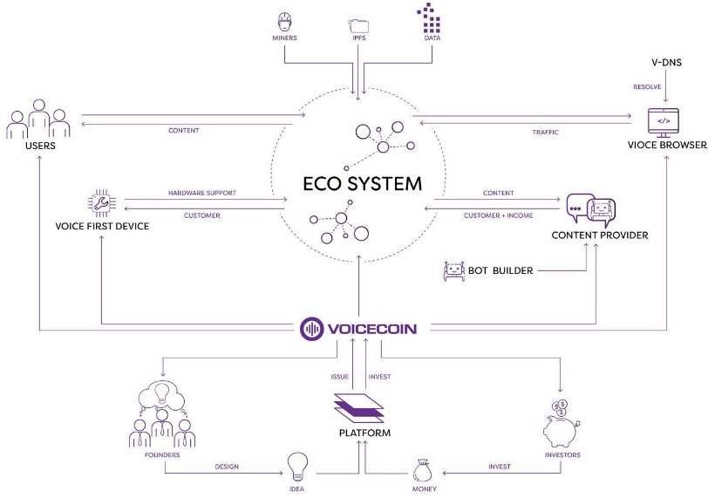
- DBot Developer.
Within this Voiceweb system, we call these chatbots DBot, or DBot Site. The Smart Speaker will utilize its own network browser, which we call DBot Browser. Platform developers, is the original chain of chain development team and suppliers. We are composed of the earliest developers of the team, the formation of the block chain foundation, which is an open community, its decision-making mechanism is open. Conversational Application Providers. Service provider, will be through our address. One, to register the domain name, bind the chat robot, to provide services to the public. With regard to service providers, in this decentralized voice internet, chatbots genuinely have a global name—they are no longer solely relegated for use inside a social platform but are open for global usage.

After the chat robot is released, anyone, anywhere with access to a smart speaker can call, use services, and make pay- ments via voicecoin. Payment histories will be logged on the blockchain. When people use chatbots, they can log in natu- rally by voice and call different chatbots, which will smoothly transition between applications without the need of repeated
log-ins and authentication.

- Consumers

Anyone, in any corner of the world, can access a smart speaker and call a chatbot. Anyone can even create their own voice home page, which can also be called by a voice speaker from overseas. So everyone may have their own dedicated voice radio station. Unlike Amazon, Google, another giants of the voice system, the domain-name system shall be open. The bots will not be deployed in the same way as the services of the giants, such as Amazon and Google, which have only one deployment. The service can be provided through intelligent voice devices around the world service.

- Miners.
Miners help the transactions are created in blocks. The miner is responsible for the construction of the block.

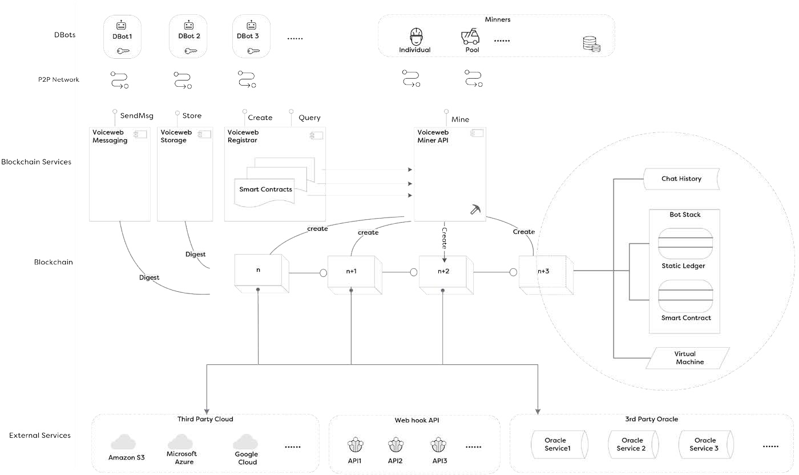
- End Users.

Through our browser plug-in, or chat robot browser, and chat with the robot communication. Chatting robot users, can also become a service provider. Both are the basic users of the platform, all have accounts and wallet, we use their address to distinguish these users. With regard to users, in this decentralized voice Internet, there is no need to bring one’s mobile phone; one can walk into any corner, find a smart device, and access any chatbot-enabled website through speech! One does not have to be tied to a cell phone; every device will be a smart device, and every device will have a voice browser. The browser can access any one of the world’s conversation-based internet addresses using the spoken domain name. Thus, the public will be connect- ed to chatbots via speech, giving rise to a whole new level of consumer convenience. The use of blockchain technology to establish chatbots, coupled with the use of smart-contract technology, will best resolve the issue of consumer confidence in these devices’ communication between people and machines, and in this way will greatly promote the greater utilization of a chatbot’s speedy and convenient services by the consumer.

- Manufacturers
Smart-speaker manufacturers may utilize the open resources on the blockchain, turning islands of information into conti- nents. This will promote the sharing of industry information, reduce development costs and access problems, and allow for the integration of various services into all smart-speaker equipment. These will include Baidu and Google and will be offered to natural-language-processing companies.

- Domain Name Owner

People will be able to buy their own exclusive voice domain name using Voicecoin. The voice domain will be registered and maintained in the form of natural language. Behind these domain names are various kinds of chatbot services. The content of these services is rich and varied. Everyone can create their own exclusive chatbot, and proxies provide chat services for other users. These chatbots will support smart contracts and may exist in a decentralized cloud. In the future, people may discover that it is cheaper to use decentralized clouds.

Conclusion

Conversation Assistant, or bot is a kind of application. Now, websites and apps usually can install bot as part of it. In the future, it's on the contrary. Every bot can have a website or apps installed as its add-ons. The basic form of application of human will be conversation interface based. Based upon this basic capability, bot will provide graphic or multimedia or virtual reality interface if necessary. This is quite different with what we think today. But we believe it will come into being. We are open to accept any company to cooperate with us. We hope the future of the next generation internet will not be controlled by any centralized companies. So, we wish people will understand our purpose, and support us generously.

All the bots have its global name and identity, which are interoperated. People can call bot name and get services. People will use more bots than apps and website. This will be a huge change that will happen in the following decades. Consumer behavior will switch again just like what happened right after Steve Jobs innovated iPhone. Well, people will liberate from incumbent internet in which people are tracked by giant companies, advertisement agency, no privacy at all. We are developing this blockchain such that the new internet will not be controlled or contaminated by the giant centralized companies

This is a conversational web, in which we don’t need to input bot name in a browser and just call bot name and got bot services, mainly in voice. Our approach is to provide people a fundamental solution for Conversation applications. Where the conversation app is, where our blockchain would be. Because where the conversation happens, where the people's privacy and security has potentially risk be infringed. We are going to innovate a new thing to solve the problem of the future. With our solutions, the new generation of apps with the future forms, we call them conversation assists, will completely put an end to those damages by stealing user's privacy data. The people's infrastructure will return to the hands of the people. User oriented, embody users assets and value, conversation, track everything, human friendly, inherit web spirit, meet the requirements of future。Based upon these fundamental factors, we use blockchain technologies, especially its decentralized and anonymity feature to rebuild the internet

References

- https://en.wikipedia.org/wiki/Internet
- "Tim Berners-Lee", https://www.w3.org/People/Berners-Lee/，2017
- https://bitcoin.org/bitcoin.pdf
- https://github.com/ethereum/wiki/wiki/White-Paper
- https://blockstack.org/whitepaper.pdf
- https://en.wikipedia.org/wiki/Domain_Name_System
- https://namecoin.org/docs/faq/
- https://www.opennic.org
- http://www.vnscoin.org/papers/white_paper_en.pdf
- https://en.wikipedia.org/wiki/Simple_Mail_Transfer_Protocol
- https://www.microsoft.com/en-us/research/wp-content/uploads/2016/06/williams2016dstc_overview-1.pdf
- https://www.ietf.org/rfc/rfc1035.txt
- https://www.w3.org/OWL/
- https://voicebot.ai/wp-content/uploads/2018/03/smart_speaker_consumer_adoption_report_2018.pdf
- http://nationalpublicmedia.com/wp-content/uploads/2018/01/The-Smart-Audio-Report-from-NPR-and-Edison-Research-Fall-Winter-2017.pdf
- http://www.baldfuturist.com/blog/2017/3/8/goodbye-gui-hello-vui
- https://en.wikipedia.org/wiki/Uniform_Resource_Identifier
- https://public.singularitynet.io/whitepaper.pdf
- https://github.com/EOSIO/Documentation/blob/master/TechnicalWhitePaper.md

.

